 | Nunburnholme with Kilnwick Percy Parish Council (PC)  Planning Applications – Process (as at October 2022)  Guidance for Applicants and Councillors

References:
- National Planning Policy Framework.
- East Riding Local Plan (Particularly policies S3-4, ENV1-6 and A3).

Policy Statement: The PC does not have a Neighbourhood Plan as it is considered Reference A and B sufficiently protect the interests of the Parish if applied dependably by planning authorities at County Council level and are applied appropriately by the PC for planning application considerations. Anyone applying for planning are advised to refer to both References, particularly Reference B. It is not intended to repeat at length what is already covered in those References, but we do emphasise that PC considerations will place great emphasis on the fact we are outside development limits of the Local Plan and consequently considered “Countryside”. So the PC will levy great weight to provisions such as: Retaining the distinctive character and landscape setting of Wolds villages, protecting the diverse character, skyline and views across the steep sided dry dales and rolling tops of the Yorkshire Wolds, establishment of a settlement hierarchy, enhancing and maintaining the vitality of rural communities, ensuring sustainable development achieved, respecting intrinsic character of our surroundings, ensuring development responds to local character and reflects the identity of our surroundings, have regard to the specific characteristics of the site's wider context and the character of the surrounding area, require development to respond to local character and reflect the identity of its surroundings, preserving existing Public Rights of Way. In addition, in June 2021, Secretary of State, announced that Natural England “will be taking forward the government’s commitment to designate additional protected landscapes and is currently considering the designation of four new areas”, which includes possible designation of a new Yorkshire Wolds AONB so the PC will also take this into consideration when considering planning applications.

Planning Considerations: Planning applications are a regular feature of council meetings and are probably one of the issues that arouses most community interests. Councillors will attach weight to each consideration based on local knowledge, judgement, evidence presented and discussed and planning conditions. The PC, whilst deciding to approve or reject an application, should always use material considerations when commenting on applications, which can include:
- Overlooking/loss of privacy.
- Loss of (sun)light or overshadowing or impact on outlook/privacy.
- Parking -insufficient or in some cases none.
- Highway safety - visibility splays sight lines; a 30mph need a 43m sightline.
- Traffic - an increase in traffic movements in a specific area.
- Noise or disturbance, impact on crime/anti-social behaviour.
- Effect on listed building and conservation area.
- Layout and density of building, incompatible or unacceptable use.
- Design, appearance, and materials.
- Government policy.
- Disabled persons' access.
- Proposals in the Development Plan.
- Previous planning decisions (including appeal decisions).
- Nature conservation; trees and landscaping, wildlife, wildflowers.
- Preserve Community Life – cumulative impact.

What Cannot be Considered: Councillors should avoid considerations such as loss of view, or negative effect on the value of properties as they are not material considerations and will be dismissed by the planning officers and planning committee. These include: Matters controlled under other legislation, Private issues between neighbours, Business competition, Loss of property value, Loss of view, Applicant’s motives, Potential profit, Opposition to principle of development at reserved matters stage, Applicant’s personal circumstances.

Representation: It is important applicants are afforded opportunity to have all evidence bought before the PC and while statutory process allows that, the PC agreed to additional measures to assist with that; these are to: directly inform applicants when their application is being considered, conduct a site visit unless a decision has been taken not to do so (in which case applicants should be told why), ensure decisions are only taken when advice is available form the Ward Councillor and Clerk, and notify applicants directly of the PC decision. A checklist is attached.

Planning Application Checklist

ACTION: | CARRIED OUT?  Insert Date | REASON FOR NOT COMPLETING ACTION:
Carry out site visit

Notify applicant of PC meeting where application will be discussed

Ensure Ward Cllr present is present at meeting where application discussed
Notify applicant of PCs decision after discussion and vote at meeting

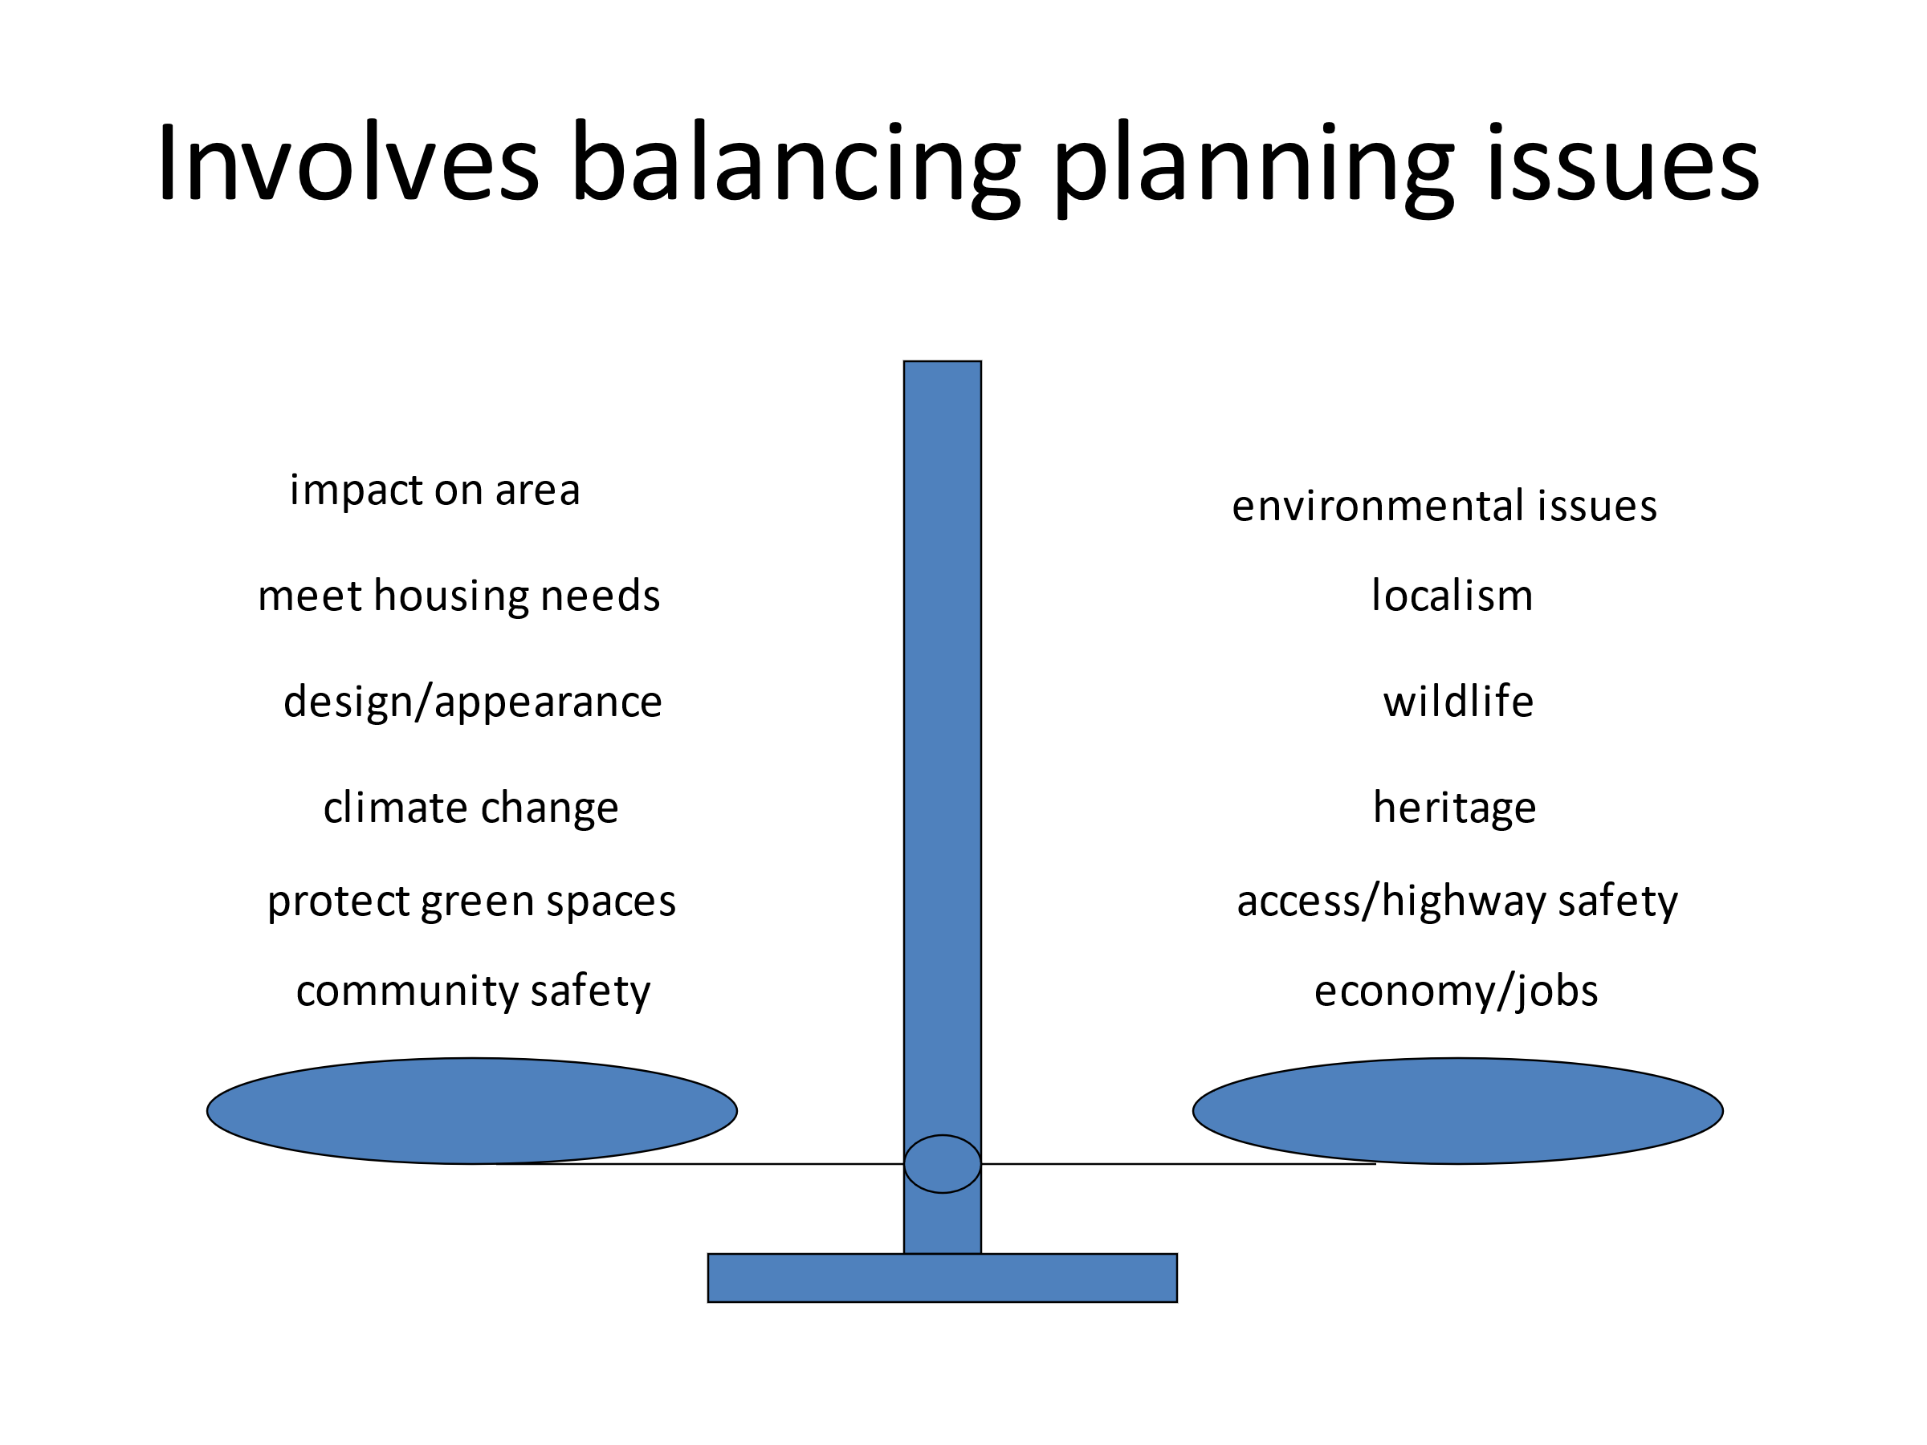

Yorkshire Wolds Designation Project (yorkshire-wolds-designation-project.org)
ERNLLCA Newsletter of 21 Oct 21

