Community Emergency Plan for the Parish of Nunburnholme with Kilnwick Percy

Level One
Updated: 7th November 2024

Section 1: Contact Directory
(to be reviewed annually)

Emergency Management Team

In the event of the plan being triggered the following Parish Councillors and members of the community have agreed to form the Emergency Management Team:

Name | Address | Telephone | E-mail
Tony Phillips
Andrew Richardson
Tom Danter
Mark Crabtree
Robert Bird
Chris Bird
Helen Halkon (Chair)

Member of Parish Council not on Emergency Management Team

Name | Address | Telephone | E-mail
Samantha O’Connor | Curlew House, Main Street, Fridaythorpe, YO25 9RS | 01377 288541/ 07815962242 | nunburnholmewithkilnwickpercy@outlook.com

Ward Councillors

Name | Address | Telephone | E-mail
Paul West |  | 01482 393939
Leo Hammond |  | 01482 393939
Derek Carey |  | 01482 393939

Community Resources

Resource | Contact Details
Tractor | Robert Bird

Organisation contact details

Fire Service, Police, Ambulance & Coastguard | 999
Anglian Water | 03457 145 145
East Riding of Yorkshire Council | 01482 393939
Electricity Emergency Service & Supply Failure | 105
Environment Agency Floodline | 03459 88 11 88
Fire Service – non emergency | 01482 565333
Gas Emergency Service & Gas Escapes | 0800 111 999
Hull City Council | 01482 300300
NHS – non emergency | 111
North East Lincolnshire Council | 01472 313131
North Lincolnshire Council | 01724 297000
Police – non emergency | 101
Severn Trent Water | 0800 783 4444
Yorkshire Water | 08451 24 24 24

Section 2: Parish Resources
<DELETE AS NECESSARY>

Meeting Venue(s)

The Emergency Management Team will usually need to meet during an emergency and agree what is to be done. The following meeting locations have been identified:

Venue | How to access | Contact Details
The Church, Nunburnholme | Keyholder | Neil Atkinson  Andrew Henworth  Helen Halkon

Public Information

The Parish Council will provide regular updates to the public during an emergency, including passing on messages received by other organisations. The following information channels can be used.

Information Source | Who can access / update? | Contact Details
Parish Council Website | Clerk | http://nunburnholmewithkilnwickpercyparishcouncil.eastriding.gov.uk/
Parish Council Noticeboards:  Notice Board 1) School House, Kilnwick Percy  Notice Board 2) Bus Shelter, Nunburnholme | Tony Phillips  Helen Halkon

Defibrillator location(s)

The community’s defibrillators can be found at these locations. Access to the defibrillator is usually given by the 999 operator following a 999 call, rather than being mobilised by the Community Emergency Team.

Location
Buddhist Retreat, Kilnwick Percy
Golf Club, Kilnwick Percy
Old School House, Church Lane, Nunburnholme

pARISH bOUNDARY map

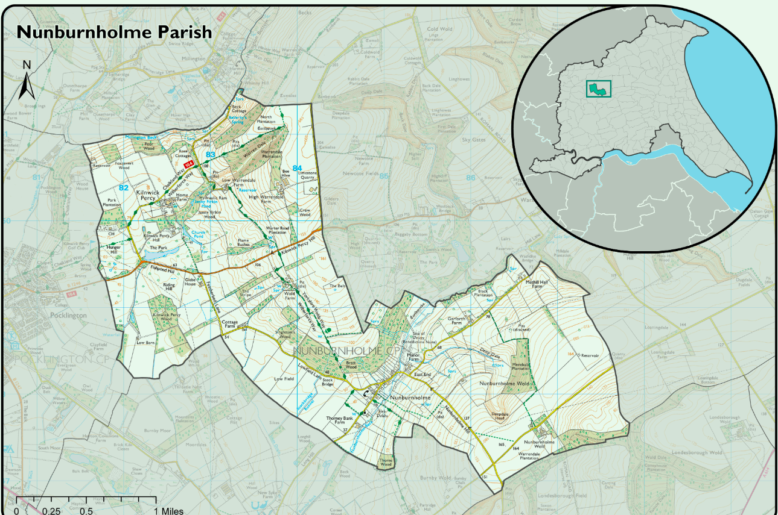

Plan Publication and Information

Plan Publication

Electronic copies of this plan have been e-mailed to:

- <heps@eastriding.gov.uk>

- Parish Councillors

The original electronic version of this plan is kept at:

- With the clerk at Curlew House, Main Street, Fridaythorpe, YO25 9RS

Backup electronic versions of this plan are kept at:

- On a USB with the clerk

Hard copies of this plan are kept at:

- With the clerk at the above address

A web version of the plan with the confidential information removed has been posted on http://nunburnholmewithkilnwickpercyparishcouncil.eastriding.gov.uk/ for public information.

Plan Maintenance

The plan should be reviewed every year in the November Parish Council Meeting. During the review every section of the plan should be checked for accuracy (telephone numbers, resource lists etc). The clerk will have responsibility for reviewing the emergency plan and should report back at the Parish/Town Council meeting to confirm that a review has taken place.

The clerk is responsible for providing an updated version of the plan to all those listed in Section 1.

Plan Exercise and Review

The Chair should make sure that all the people who are involved in the plan are aware of their role, and know that that they might be contacted during an emergency.

Data Protection

This plan will contain personal information once complete. Town and Parish Councils should follow their data protection procedures when completing, maintaining and storing this plan.

